Study Guide Answers
- Anything that has mass and volume
- Characteristic that does not involve chemical descriptions (can generally be observed with your five senses) Ex: density, color, hardness, state of matter
- Property of matter that makes a substance capable of chemical reactions. Examples would include, flammability, combustibility, acidity
- Examples of physical change: state of matter changes, (melting, evaporating) color changes when they’re expected
- Examples of chemical change: rust, fire, cooking food, digestion, baking soda and vinegar
- LOC: matter cannot be created or destroyed, simply change phases
- LOW can be demonstrated by recording the starting and ending mass of reactants and products before and after a reaction in a closed reaction. ( think of the flask, balloon, alka-seltzer lab)
- Atom is the smallest unit of an element that maintains all the properties of that element (for example, gold cannot be broken down past its atomic structure and still be gold)
- Molecule is the smallest unit of a substance that keeps all the physical and chemical properties of that substance. (NaCl- salt- can’t be separated or it isn’t salt)
- Pure substance- contains only one type of particle. Examples would be element or compound.
- An element is a substance that cannot be separated or broken down into simpler substances.
- A compound is a substance made up of atoms of two or more chemical elements joined by chemical bonds (O₂ or H₂O)
- Mixture- two or more substances that are not chemically combined. (salt water)
- Pure substances have only one type of particle, and mixtures have more than one type of particle.
- Slowest to fastest from solid to gas and plasma, and energy is increasing as particles begin to move faster.
- Metals are malleable, ductile, are good conductors
- Metalloids have characteristics of metals and nonmetals (like silicon, which is a semiconductor)
- Nonmetals are usually poor conductors
- PT is organized according to atomic number (protons) and reactivity increases as you move from left to right across the table.
- AN tells you the number of protons in the nucleus of an atom.
- Families are the “columns” on the periodic table, also called groups. Elements in a “family” or “group” all share common characteristics and properties. Noble gases are non-reactive and Alkali metals are highly reactive. Families are named according to the element at the top of the column.
- Noble gases are non-reactive elements found in the 18th column on the PT, or group 8. They all have a full shell of valence electrons and don’t react easily.
- Table salt (NaCl), water (H₂O), carbon dioxide (CO₂)
- LOC of energy states that energy can never be created or destroyed
- PE is energy of position or shape
- KE is energy of motion
- 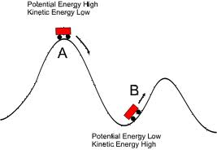

- 7 forms of energy
Electrical
Chemical
Nuclear
Sound
Heat/thermal
Light
Mechanical

- Temperature is the measure of the average kinetic energy of a substance. Thus, as the particles move faster, temperature goes up, as particles move more slowly, temperature goes down.
- Heat is the transfer of thermal energy
- Thermal energy is the total amount of energy of the particles that make up a substance
- And 33. Conduction – trough touching, convection – through the movement of convection currents created by uneven heating of liquids and gasses, radiation - traveling through empty space
- See above
- Thermal energy is the total energy of an objects particles and temperature is the measurement of the average kinetic energy of an object. Heat is the transfer of thermal energy.
- As matter heats up, the particles in that matter move about with more energy. This causes the matter to expand because of that increased motion. The opposite happens when matter loses heat.
- A reflection is when a wave bounces off of a surface
- We see the reflection of light off of those objects
- Refraction is the bending of light as it changes from one medium to another
- Mirrors reflect the light waves because of their shiny surfaces
- Lenses work by bending, or refracting, light as it goes through them
- Objects have different colors because they reflect a certain wavelength of light while absorbing the other wavelengths.
- As white light (all the colors together) enters a prism the light is bent (refracted) into its individual wavelengths

- 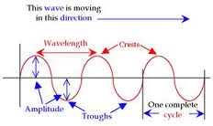

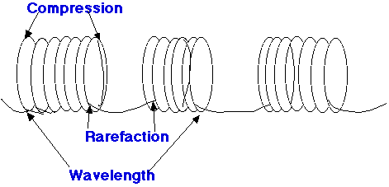
- A vibration is the moving of a particle back and forth in place
- A wave is the transmission of energy through the vibration of particles
- The frequency of a wave is the amount of waves that pas a certain point in a certain time period. This is usually one second and is measured in Hertz (Hz)
- Wavelength is the distance from one point on a wave to the exact same point on the next wave.
- Amplitude is the distance from the resting point to the trough or rest. This is a measure of the energy in a wave.
- Amplitude indicates how much energy is in a wave
- The Doppler Effect is the apparent shift in pitch as a source of sound moves toward or away from us. As it moves toward us we encounter its sound waves more quickly causing the apparent frequency to increase causing an increase in pitch. As it moves away from us the opposite happens.
- Pitch refers to the frequency of a sound wave
- Amplitude is the amount of energy in a wave. Volume depends on the energy of a wave. Higher amplitude means higher volume
- When frequency goes up so does pitch
- Energy conversions are when one from of energy is changed into another. Such as when electric energy is transferred to heat and light energy in a light bulb.
- Work is the amount of force used over a certain distance. W=F x D
- Friction is the force that opposes motion. Friction always transfers some of the energy of motion in to heat energy
- Greater mass = greater gravitation. The closer objects are, the more the greater the gravitational attraction will be between them.
- Mass is the amount of matter that an object has. Weight is the effect of gravity on that matter.
- Speed is the amount of distance traveled in a specific time. S=d/t
- m/s
- Velocity is speed in a certain direction. V=d/t
- Acceleration is the change in speed or velocity over a period of time. (V²-V¹)/t
- 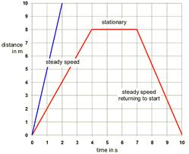

65. Lever- see saw, inclined plane- ramp, screw- bottom of light bulb, wheel and axel – car drivetrain, pulley- elevator, wedge- knife
66. Force is a push or a pull. Mass is how much matter is inside of an object. Inertia is the tendency of an object to resist changes in motion. Force = Mass x Acceleration
67. A balanced force results in no change in motion. An unbalanced force results in a change in motion.
68. Inertia is the tendency of an object to resist changes in motion.
69. 1st = Law of inertia. 2nd = Force equals mass times acceleration (F=M*A) 3rd= for every action there is an equal and opposite reaction.
70. For work to be done, you must apply a force on an object that results in movement of the object in the direction of the force.
71. Power is work/time.
72. Power is work/time.
73. Flow of electrons
74. Build-up of a charge in an object
75. Load, path, and source
76. Series uses less wires and less wattage, but one bulb going out effects all other bulbs. Parallel circuits have fewer wires but each load has its own path to the source, so it uses more power but if one load goes out, the others still function.
77. Generator transforms kinetic energy into electric energy by spinning magnets over coiled wire.
78. 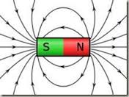
79. An object that gains a magnetic field when exposed to an electric current and a coiled wire.
80. A solenoid is a type of electromagnet.

